COIN HTM No. 43

THE challenges OF COMPLETIONS, interventions, and well Abandonment in a low oil price environment

Hosted by Expro Aberdeen - 21th October 2015

MEETING NOTES

The meeting introductory remarks included an anti-trust reminder to ensure that all of the participants conform to the applicable laws and regulations during the course of the meeting.
OGIC presentation - Ian phillips, oil & gas innovation centre chief executive
Ian’s introductory remarks noted that the oil and gas industry tends to be myopic and internally focused and therefore misses opportunities for potential external funding and support services for R&D projects. These enabling sources of funding and support services include governmental organizations, Universities, and a variety of non-profit organizations focused on new technology and innovation collaboration as described in slides two through five.
A Technology Readiness Level (TRL) framework helps to understand the role and in what scenarios and time frames these enabling organizations can assist. The Technology Readiness Levels, ranging from TRL 1-9, is portrayed on the right hand side of slide 2. Levels 1-3 roughly correspond to the basic research which is typically conducted at Universities, with Level 1 representing the ‘eureka” moment for a novel invention. Levels 4-9 represent technology innovation that occurs in Universities, non-profits, and business organizations. Levels 7-9 are typically in the business domain and represent new product development. An example is the next iPhone under development by Apple, which would correspond to Levels 7 - 8.
The UK government funding to Universities for basic research is significant, totalling almost $3B GBP for the period 2012-2013. The UK government funding to companies for innovation through the Innovate UK Technology Strategy Board totals almost $1B GBP for 2014-2015. Scotland launched the Innovation Centre Programme about a year and a half ago which includes technology innovation collaboration organizations such as OGIC shown on slide 5. CENSIS is an example of another Innovation Centre organization. The focus of both OGIC and CENSIS is most applicable to the oil and gas industry.
The mission of CENSIS is to educate key stakeholders in what technology is already available, but not being fully exploited, or “the art of the possible”. The Data Lab organization focuses on big data - the collection and management of large data sets to help pinpoint trends or anomalies that have value to the user. OGIC began operations in November of 2014, their charter being to nurture innovation in the UK oil and gas industry. They do this through helping oil and gas companies identify and articulate their business needs that are not being met with existing technology, then connecting those companies with the best Universities that can help them develop and productise the new technology. OGIC can also play a role in offering technical and other types of advice (e.g. State Aid constraints, IP management, project structuring, timescales) to shape the proposed project, and then project managing the technology through the innovation life cycle.
OGIC helps guide the companies through a matchmaking process and the maze of Universities in the UK, focused on the 14 Universities in Scotland, to ensure the selection of the best collaboration partner. OGIC can also offer funding in some cases in the early stage of the project. The seven steps in the typical project application process are shown on slide 7. The process is kicked off when companies approach OGIC with a specific challenge. The timescale of the effort to address the challenge can range from 3-6 months for a small scale project, to 6-24 months for a larger scale effort. Quite often a phased approach is taken, with Phase 1 comprising the initial 3-6 month effort, followed by a Phase 2 of 6 -24 months. A Project Review Panel is in place to screen the proposed projects for originality and relevance. Slide 8 describes a pre-project workshop approach that can also be taken.
Participating company feedback on this approach indicates that the engagement by the companies with multiple Universities that participate in the Expression of Interest is particularly valuable due to the dialogue with an objective, expert party that is not competitive with the company from a business standpoint. OGIC helps to manage the IP issues associated with this, and ensures that the company owns the IP, with the University chosen as a partner that secures the rights to use the technology in perpetuity in a non-competitive fashion for teaching and research.
The timeframe to identify the University best suited for the company and secure project approval has ranged from two to six months, with six projects currently approved. Ian described a couple of the projects to provide an overview of the type of projects that are underway and to illustrate the wide range of project types:
One involves the development of a high pressure subsea hose that offers superior performance through the use of Kevlar instead of steel in the hose construction. Phase 1 of this project is in progress and intends to demonstrate how durable the solution is in the challenging offshore environment.
Another project is targeted to use an existing patented corrosion resistant coating process that is designed for flat surfaces, and apply it to the coating of curved surfaces. A third project involves the development of an augmented reality software solution that enables mobile devices like an iPad to identify and present detailed equipment information without the use of barcodes.
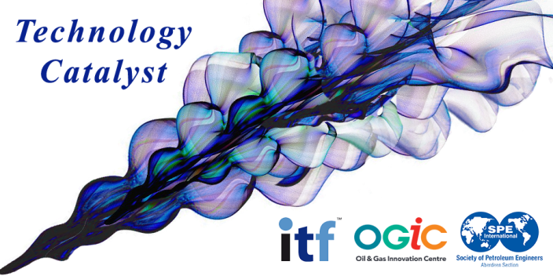
Ian described a Technology Catalyst Series that has been initiated as a joint effort by OGIC, SPE, and the non-profit Industry Technology Facilitator (ITF) organization. ITF is a membership of international oil and gas operating and service companies that brings forward collaborative funding for research and development initiatives that address shared technology challenges.

The first Technology Catalyst event focused on Well Integrity Tool was conducted in August. This first in a series event was attended by over 40 representatives from industry and academia. The purpose was to develop ideas for addressing the specific challenge of evaluating well integrity without a drilling rig and prior to well abandonment.
The four topics discussed were:
- Constraints within which solutions must fall
- Existing sensing technology
- New or novel sensing technology
- Combining existing and new technology.
The output from the workshop is being prepared and will be shared publicly. More information on this event and how to obtain a copy of the event report is available at http://www.ogic.co.uk/well-integrity-tool-workshop/.

The Use of digital echometers to determine liquid levels in annuli - marc prickett, Intervention rentals

Marc described how the application of digital technology and best practice methods with an echometer offers improved results over conventional analog technology and methods. The paper charts associated with the analog technology can be difficult to read and often result in multiple interpretations. The digital technology provides the data on a screen, with more consistent results, enhanced by use of a noise filter to clean up the signal.

A combination of correct installation and operation was discussed in order to achieve the best results. Verification in the correct use of the digital technology for high liquid level detection in low pressure applications was highlighted in development and use of a simulated well assembly and annulus space. Extensive testing on this assembly at various charge pressures were taken to check the repeatability and clarity of the returned signals.
Slide 6 was used to indicate the difference made by employing the noise filter. This cleaner signal thus improves analysis and interpretation of the signals providing the ability to recognize patterns and determine the liquid level.
Slide 8 provides an understanding of the importance in selecting the right charge pressure with which to obtain the best signal for analysis. Loss of detail can be as a result of the wrong charge pressure is some cases.
Slide 9 illustrates the value of taking multiple shots. All three of the cases presented on this slide were taken at the same pressure. Generally five shots are taken at three different pressures each, with the data analyzed to determine if the marker of interest is always in the same place. In some cases, anomalies in the data can be created from setting off the shot.

The use of a simulated well assembly has been critical in verifying the validity of signal in high liquid level applications with low pressure annuli; developing best practice methods, and also as a training environment for service company staff. A more important method of verifying the results of echometer analysis during live operations was achieved by physical topping up of the annulus with the appropriate fluid. The net effect of multiple echometer operations which involved top-ups was an increased confidence level in the use of this technology.

One OpCo rep noted that they use the technology routinely in the UK, especially with annuli. A couple of the challenges they have experienced include the interpretation of the data and determining what type of fluid they are shooting into (for example, air versus N2).

Another OpCo rep also indicated that the technology is being used routinely to determine if gas lift valves are leaking, and securing an integrity test on packers. The technology has been proven to be accurate and very valuable for troubleshooting well integrity issues.

overview of lower completion sliding sleeve systems & track record – Tom Rune Koloy, Trican

Tom provided an overview of sliding sleeve systems associated with well fracture multistage stimulation. They have been developed and deployed to provide an alternative to conventional plug and perf methods. This system was developed after Trican was approached by a client to help them make completions more efficient. A series of field trials and tests were conducted to fully develop and prove the effectiveness of the technology.

Two completion system types are typically used - a cemented reservoir liner or a Liner-in-Liner. For the cemented reservoir liner system portrayed on slide 4 and 5, up to 20 sleeves have been used per interval. This system is ISO barrier qualified (14998 V0) with the sleeves opened through the use of a ball. The Liner-in-Liner system portrayed in slide 6 is typically used for new wells, and provides life of well intervention capability. This system provides some of the functionality of smart wells, plus acid stimulation capability that is required before the well is put on production. Chemical tracers which are oil and water soluble can be used to pinpoint which zone is producing the material. The positive results obtained through the use of these systems include reduced completion time and cost (from 3 weeks to 3 days), improved reservoir surveillance, and reduced HSE risk of handling explosives offshore.

Currently two major operators are using these systems, with the systems installed on about 30 wells in the UK and 300 wells in North America to date. Slide 10 presents data compiled by one operator using both conventional plug and perf and the two ball drop sliding sleeve systems. This illustrates that all three of the technologies provide roughly the same quality of stimulation and post stim skin factor. A skin factor of -3 or below is considered to be a good result. This graph demonstrates the value delivered by the ball drop sliding sleeve systems given the reduced costs, time, and other benefits. Wells that have used these systems have been producing for 1-2 years, with repeated operation of the sleeves and no failures reported. Tom clarified that RESMAN is the tracer supplier.

One OpCo rep noted that there may be situations where the use of ball drop systems may not be appropriate given the well downhole configuration. Also, it was noted that the focus for the North America region is efficiency, versus the North Sea where the need for flow control capability is more important. Tom clarified in response to a question that sliding sleeve equipment is available that capable of either one time or multiple sleeve activation. He also clarified that the sleeve is either fully open or closed and does not offer any partial flow choking capability, and that intervening with a shifting tool on a tractor is an option.

Roundtable (‘Quick-fire Questions’) Session #1

Topic 1 – Installation of pressure gauges for long term observation in an abandoned well.

An OpCo member described a situation where an exploration well in PNG will be abandoned after reservoir data has been acquired, and the desire is to be able to use that wellbore as an observation well post abandonment to monitor reservoir pressure. The member asked for any proven technology that would meet this need. A ServCo member responded that Expro has had successful applications of this technology, as described in several SPE papers listed below. Brian Champion, with Expro, was mentioned as the best contact for any direct follow up.
SPE 108435, Clair Field: Reducing Uncertainty in Reservoir Connectivity During Reservoir Appraisal - A First Time Application of a New Wireless Pressure Monitoring Technology in an Abandoned Subsea Appraisal Well
B.P. Champion (Expro), I.R. Searle and R.K. Pollard (BP plc)

SPE 102547, Novel Wireless Solution to Address uncertainties in Reservoir Connectivity
B.P. Champion (Expro)

SPE-175075-MS, Reducing Reservoir Uncertainty During Appraisal and Development - Novel Applications of a new Wireless Reservoir Monitoring Technology in Santos Basin Pre-Salt
B. P. Champion (Expro, E. A. Puntel (Petrobras)
Another member mentioned that the use of DTS could be an option, with the fiber optic cable run on the outside of the casing. This is currently being done on horizontal wells.

Topic 2 - Subsea well gas lift valve troubleshooting when multiple wells have a commingled gas lift supply line.
An OpCo member requested input on how best to test gas lift valves (GLV) on subsea wells without blowing down the annulus. It becomes a challenge when you blow down the annulus in subsea wells that have a commingled gas lift supply line since this will cause severe production losses from all the other wells that share the line as well as result in flaring of gas. The schematic below illustrates the well configuration.

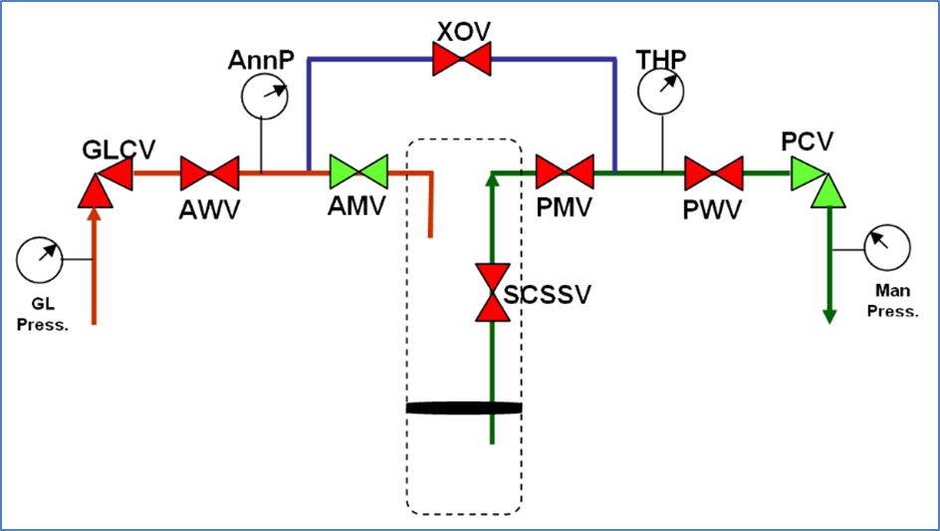

An OpCo member suggested isolating the annulus by closing the outer annulus wing valve (AWV) to isolate the well and then blowing down the annulus using the crossover valve (XOV) on the tree.

The questioner responded that this still presents challenges. Firstly, even if you blow down the Annulus over the XOV valve you still have the ambiguity of whether or not the GLV is the one leaking because in effect you are testing the entire annulus and other equipment could be leaking e.g liner laps, tubing connections, Packer seals etc...

Secondly, without blowing down the GL line there is still a high pressure source on the back side of the AWV (ignoring the GLCV as this isn’t normally classed as a barrier and often leaks). If the annulus pressure builds up then you are unsure if it’s a downhole leak (tubing or GLV) or an AWV leak. Also, you are relying on the tubing/reservoir to be sufficiently pressured up to act as a pressure source to be able to positively test the GLV in the tubing -> annulus direction.

Another OpCo member suggested that the existing GLV could be replaced with high integrity GLV for improved performance. The risk of casing collapse when blowing down the annulus was raised, but the questioner noted that only partially bleeding it down would mitigate this risk.

oil & gas uk well life - cycle integrity guidelines - stuart connon, total

Stuart provided an overview of the well life-cycle guidelines developed for the UK region. These guidelines were developed post Macondo based on a study and recommendation of the Oil Spill Response Advisory Group (OSPRAG) Technical Review Group (TRG). The TRG concluded that there was a high degree of confidence in the UK regulatory regime. The Group recommended the formation of a standing body, the Well Life Cycle Practices Forum under the stewardship of Oil and Gas UK (OGUK). The WLCPF comprises representatives from the 42 well operators and 5 well management company members of OGUK, and interfaces with the IADC, the Well Services Contractors Forum, the Health and Safety Executive (HSE), and the Department of Energy and Climate Change (DECC). The Forum and guidelines progress the recommendations made by the Technical Review Group.

Since the OGUK is a trade association of operators and contractors –unrelated to government and regulators - the guidelines have been developed by users, for users. They are intended to be something the person on the rig can pick up and apply. The guideline is not prescriptive, and references specific industry standards such as ISO and NORSOK instead of trying to replicate them. The guidelines are applicable to all UK wells, both onshore and offshore.

A draft of Issue 3 of the guidelines will be out in a few weeks, with a target to publish them in the beginning of 2016. Stuart noted that the use of the guideline is being implemented within Total, with gaps and non-conformances identified and actions taken to close the gaps. He also noted that other operators are also measuring how well they are meeting the guidelines, with some operators adopting the guideline as their company WIMS.

well integrity throughout the lifecycle of the well - simon copping, expro
Simon described the genesis and evolution of the SafeWells software solution over a ten year time frame. The app manages well integrity risk throughout the lifecycle of the well. Currently 22 operators are using the system and are members of a user group that provides input on new product features that are under consideration. Simon indicated that the typical time frame to fully implement a system like this for a global operator is about a year, and could be less (3 - 6 months) for a smaller regional operator.

One member suggested that consideration be given to using the collective data across all of the operators to collect and publish industry reliability data. An analogy to this is the Rushmore drilling performance database, which publishes metrics based on data collected from multiple industry operators.

However, an OpCo member noted that reliability metrics may be operator specific based on a relative risk ranking, which may complicate developing agreed shared metrics for the industry.

Another member suggested that if the existing SafeWells data could be used to generate metrics on the variation of testing frequencies and equipment failure rates across the industry, then this might wet the users’ appetite for mining more data from the solution.

Roundtable (‘Quick-fire Questions’) Session #2

Topic 1 – Water injection well downhole valve leakage.

A member asked for input on how best to address a situation where leakage of a downhole water injection valve needs to be assessed and remedied.

Member responses indicated that API 14B still applies with the same criteria as oil or gas producer. However, the response to any anomalies identified may vary based on the severity of the well specific risk factors. An example of this is whether the well is connected to hydrocarbons resident in the injection zone.

Another member suggested that a baseline equipment performance data point should be established prior to completion of the well and then monitored after that. This can be accomplished by building a test stump, testing the valve at the beach, then taking it to the field and testing it again. This would establish the baseline performance of the valve, and demonstrate how the risk has been assessed and managed.

Brainstorm List of Potential Future COIN HTM Topics
Members contributed the potential topics listed below:
- How to get more bang for the buck - maximizing economic recovery
- Sharing lessons learned - a global perspective
- Technology updates
- Innovating and improving the efficiency of abandonments
- Marine vessel utilization

END

